Clean Code

📌 Definition:
# Source: AI Source: Provided by: [Data Path: Persons Table -> ID Column: 1, Name_En Column: Motasem Essam] -> From: [Chatgpt (GPT‑5 Mini)] on [12/9/2025]
Clean Code is code that is easy to read, understand, and maintain, written in a way that is simple, clear, and well-structured.

🧠 Simple idea:
# Source: AI Source: Provided by: [Data Path: Persons Table -> ID Column: 1, Name_En Column: Motasem Essam] -> From: [Chatgpt (GPT‑5 Mini)] on [12/9/2025]
Clean Code = “Code that is easy for humans to read” 👁️

🔍 Key characteristics:
# Source: AI Source: Provided by: [Data Path: Persons Table -> ID Column: 1, Name_En Column: Motasem Essam] -> From: [Chatgpt (GPT‑5 Mini)] on [12/9/2025]
- 📖 Easy to read and understand
- 🧩 Well-structured and organized
- 🧠 Uses meaningful names for variables, methods, and classes
- ⚙️ Avoids unnecessary complexity
- 🔄 Easy to maintain and modify
- 🧪 Easy to test

📌 Clean Code Principles:
# Source: AI Source: Provided by: [Data Path: Persons Table -> ID Column: 1, Name_En Column: Motasem Essam] -> From: [Chatgpt (GPT‑5 Mini)] on [12/9/2025]
Clean Code Principles are a set of guidelines and best practices that help developers write clear, readable, maintainable, and efficient code.
Here is a complete, clean, and rewritten set of Clean Code Principles, combining everything from both of your lists into one structured guide:
✍️ 1. Use Meaningful Names
- Names should clearly express intent and purpose
- Avoid vague or misleading names
- Good names reduce the need for comments

📝 2. Meaningful Names Over Comments
- Write self-explanatory code
Use comments only when necessary

📏 3. Keep Functions Small
- Each function should do one thing only
- Small functions are easier to read, test, and reuse

🧩 4. Single Responsibility Principle (SRP)
- Each class or function should have one responsibility
- Avoid mixing multiple concerns in one place

🔁 5. Don’t Repeat Yourself (DRY)
- Avoid duplicate code
- Reuse logic through functions, modules, or utilities

🧠 6. Keep It Simple (KISS)
- Prefer simple and clear solutions
- Avoid unnecessary complexity

🔄 7. Refactor Often
- Continuously improve and clean your code
- Refactoring keeps the codebase maintainable over time

📦 8. Encapsulation
- Hide internal details and expose only what is necessary
- Protect data and control how it is accessed

🎯 9. Be Consistent
- Use consistent naming, formatting, and structure
- Consistency improves readability and teamwork

🎨 10. Follow Code Style and Indentation
- Use proper formatting and indentation
- Follow a standard style guide

🔍 11. Write Pure Functions
- Functions should:
  - Have no side effects
  - Always return the same output for the same input
- Improves predictability and testability

🚫 12. Avoid Deep Nesting
- Too many nested conditions reduce readability
Use early returns or refactoring to simplify logic

⚠️ 13. Minimize Cyclomatic Complexity
- Avoid overly complex logic and too many branches
- Keep conditions and control flow simple

🚫 14. Avoid Passing Nulls and Booleans
- Avoid null as a value
- Avoid boolean parameters in functions
- Prefer explicit and clear alternatives

🧱 15. Keep Framework Code Separate
- Separate business logic from framework-specific code
- Makes code easier to maintain and test

⚙️ 16. Use the Right Constructs
- Choose the most appropriate language features
- Write code that clearly expresses intent

🧱 17. Organize Code Properly
- Group related code together
- Follow a clear and consistent project structure

🧑‍🤝‍🧑 18. Organize Code by Actor (or Domain)
- Structure code based on the user or domain it serves
- Improves clarity and scalability

🔗 19. Command Query Separation (CQS)
- Separate:
  - Commands → modify state
  - Queries → return data
- A function should not do both

⚙️ 20. Avoid Hardcoding
- Use constants or configurations instead of fixed values
- Makes code flexible and maintainable

🧪 21. Write Fast and Independent Tests
- Tests should:
  - Run quickly
  - Not depend on each other
Ensures reliability and stability

🧪 22. Write Testable Code
- Design code so it is easy to test
- Leads to better design and fewer bugs

📌 23. Follow Proper Structure
- Maintain logical file, class, and module organization
- Improves navigation and maintainability

📌 Example:
# Source: AI Source: Provided by: [Data Path: Persons Table -> ID Column: 1, Name_En Column: Motasem Essam] -> From: [Chatgpt (GPT‑5 Mini)] on [12/9/2025]
❌ Bad Code:
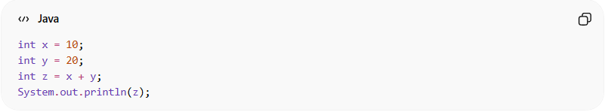
int x = 10;
int y = 20;
int z = x + y;
System.out.println(z);
✅ Clean Code:
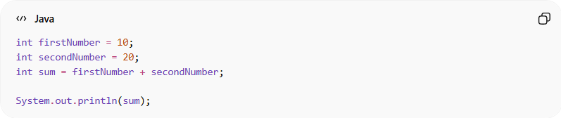
int firstNumber = 10;
int secondNumber = 20;
int sum = firstNumber + secondNumber;

System.out.println(sum);
👉 The second version is easier to understand.

🎯 Why Clean Code is important:
# Source: AI Source: Provided by: [Data Path: Persons Table -> ID Column: 1, Name_En Column: Motasem Essam] -> From: [Chatgpt (GPT‑5 Mini)] on [12/9/2025]
- 🧩 Easier to maintain
- 🔄 Reduces bugs
- 🧠 Improves readability for teams
- ⚙️ Saves time in the long run
- 🤝 Better collaboration

🎯 Summary:
# Source: AI Source: Provided by: [Data Path: Persons Table -> ID Column: 1, Name_En Column: Motasem Essam] -> From: [Chatgpt (GPT‑5 Mini)] on [12/9/2025]
Clean Code is code that is simple, readable, and easy to maintain, making it easier for developers to understand and work with.
Clean Code is not about following rules blindly—it’s about writing code that is easy for humans to read, understand, change, and trust.

